INVATAM LA PROGRAMARE!
------I hate this woman!------

Pre-processor directives
So, we have a function defined MAX(a, b), then we expressed the function between the brackets, using logical ?, and we surely return a or b. Inside main block, we just called MAX function inside the printf.
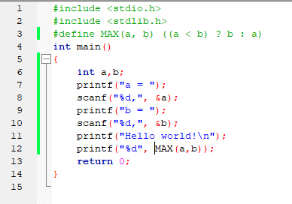
We can take another example here, where we created the function PLUSDOI. Our function returns an integer, a, and what it’s doing: adds 2 to the number we introduce (a). Pretty simple, eh?
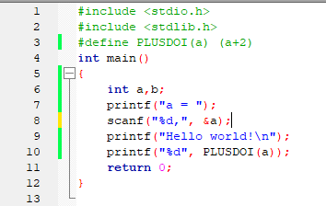
!! There also exist #warning and #error which can be used to display a message.
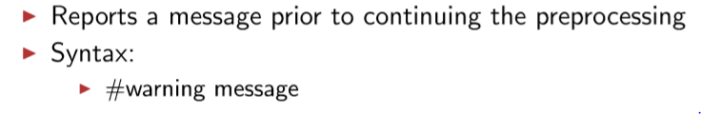
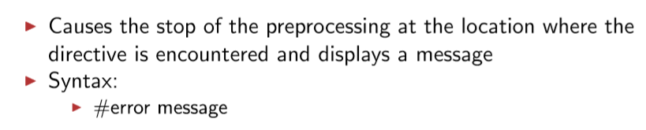

Pointers and addresses

- So, we can have different data types. For example, integers (that hold 4 bytes of memory) or characters (that hold 1 byte of memory) need to be stored somewhere, randomly, in the memory so we use RAM (Random Access Memory)
if we declare an integer
int a = 10;
then we can say integer a is stored in a location (choose a random no.: 269) and at that location is stored the value of a, 269
so:
a = 10
&a = 269 address of a (& - ampersand – and – address)
We can make a new variable, called an integer pointer that holds the address of a.
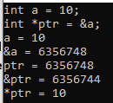
int *ptr = &a;
so, now we have:
a = 10
&a = 269
ptr = 269
&ptr = 308 (new place in memory, ofc)
*ptr = 10 (the value found at the address that our ptr was holding)
& - referencing a pointer, * - dereferencing a pointer
!!valoarea gasita la adresa stocata in pointer!!

- we can have pointers to void; we know that there exists a pointer, but it doesn’t have yet any value to reference to in this way we can save some more space :D
void *ptr; here we have a pointer to void.\
int a = 10;
declared a – int, and b – float
float b = 7.0f;
ptr = &a;
we referenced to both variables with the same ptr
ptr = &b;
and now, for printing out, we just have to use the type cast (data_type *)
printf(“%d”, *(int *)ptr); will give us value of int a, which is 10
printf(“%1.f”, *(float *)ptr); will give us value of float b, which is 7
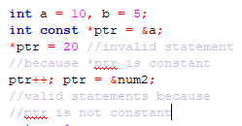
- we can also have:
so, we can’t change the value
- pointers to some constant value
if ptr not constant, then we can play with the address
const int *ptr = value;
int const *ptr = value;

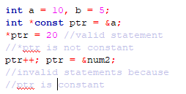
if ptr constant, then we can not play with the address
so, we can change the value

- constant pointers
int *const ptr = value;

- some notions about pointers arithmetic
- a pointer can be decremented (++), incremented (--), integers may be added or subtracted from pointers, and ofc, pointers can be added or subtracted from pointers.

!! ptr + n == ptr + n * sizeof(ptr data_type) !!

- usually, pointer arithmetic, is meaningless unless performed on ARRAYS.
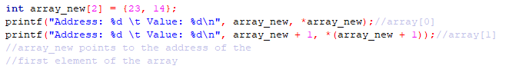

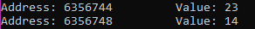

- so, what we can see is that the name of the array holds the address of the first element of the array.
- if we make a new int pointer that will point to array[0] we can use it as well as the array’s name pointer
- the crazy and awesome thing we can see is that the following statement is an equality!
array_new[1] = *(array_new + 1) = *(ptr + 1) = ptr[1]
and ofc
array_new[0] = ptr[0] since ptr is an in pointer that stores the address of the 1st element of the array
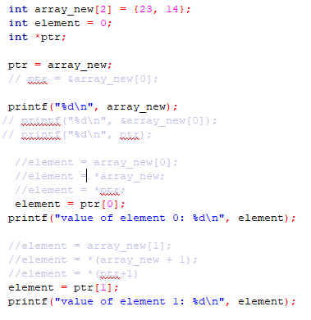
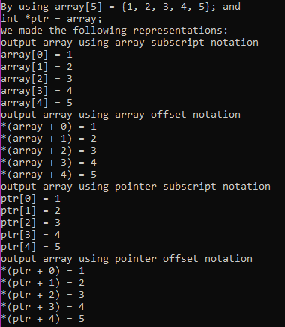
Remark
*++ptr – moves to the next address and takes the value
++*p – takes the value and increments it
in the following example we have some various examples regarding the ways in which we can represent arrays
CHARACTER arrays & pointers
- some examples about char strings and char characters
- mandatory to use [ ] !!
- below you can see more ways of finding the same character (“r”), using subscript or offset, array or pointer notation.
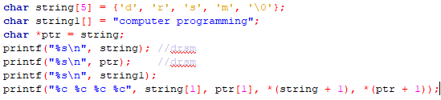
- we have two ways of printing a string[] presented below; either we increment i and use the pointer subscript notation, either we increment the address where we do our search (ptr), using the pointer offset notation
- we can also use the array method to print out the content of the string (string[i], i++)
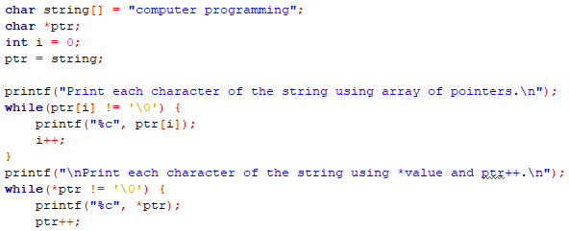
ARRAYS OF POINTERS
Yes, we can have arrays of pointers!
int *ptr[n];
ptr[i] = &array[i]
printf *ptr[i]
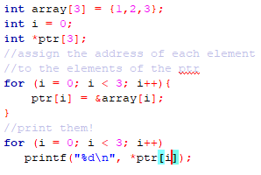
- we use arrays of pointers to form arrays of strings
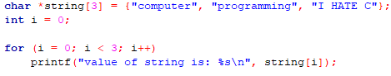
- without using the *, our program wouldn’t have returned anything (just errors and warnings)
POINTER TO POINTER
- chain of pointers
int x = 1;
int *ptr_x;
int **ptr_ptr_x;
ptr_x = &x;
ptr_ptr_x = &ptr_x; ptr_ptr_x is a pointer to a pointer to an int
- blablabla

FUCNTIONS
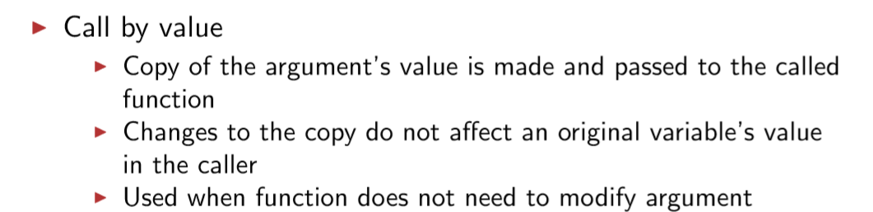
- cand apelam cu valoare, nu se va “afecta” valoarea originala a variabilei
- putem simula call by referene folosind pointeri, pentru a modifica si valoarea initiala a variabilei din argument
exemplu:
- aici nu folosim referinte, si atunci, dupa ce facem swap, doar in interiorul functiei se produc modificari
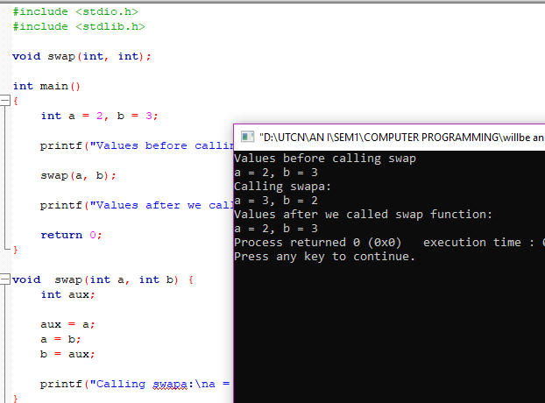

- aici, am apelat in main functia swap(&a, &b) care acceseaza adresele variabilelor a si b deci produce modificari la nivelul adreselor
- in functie, am lucrat doar cu *a *b deoarece ne dorim sa modificam valorile acestora pentru totdeauna :D

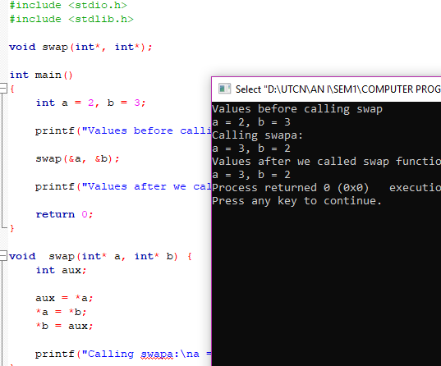

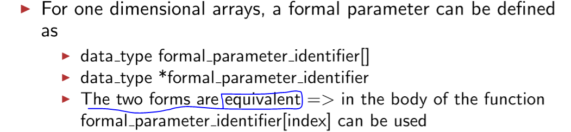

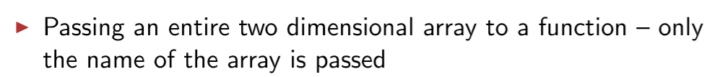
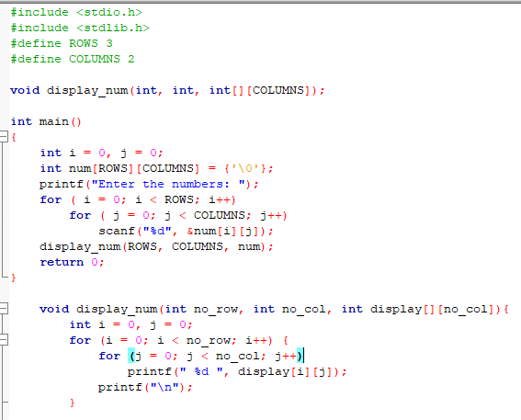

CTYPE FUNCTIONS
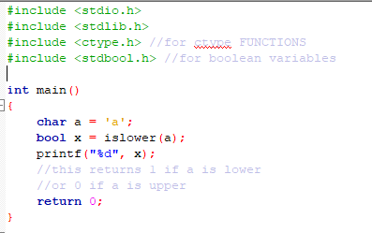

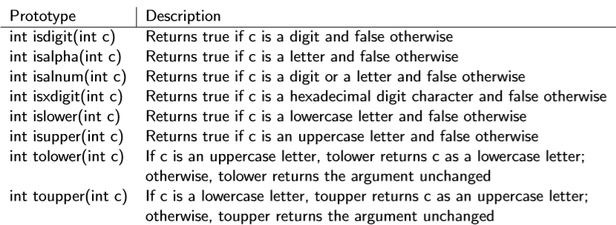

MATH.H
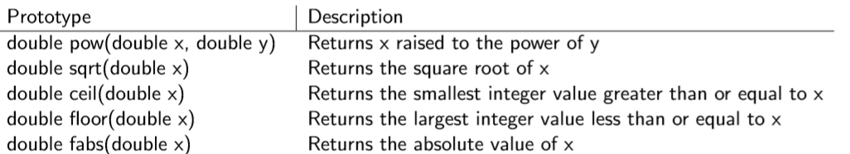

POINTERS TO FUNCTIONS
- ce se intampla aici: se creeaza fptr care poate substitui o functie ce returneaza int si are doi int ca parametru. de aceea noi mentionam fptr = sum.
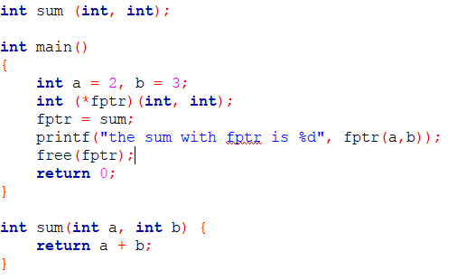
- PASSING FUNCTIONS AS ARGUMENTS TO FUNCTIONS
void(*fptr)(int) – return_type (*f_name) (arguments)
- when we call it, we don’t use any arguments, since in the “mother” function we called fptr(20)
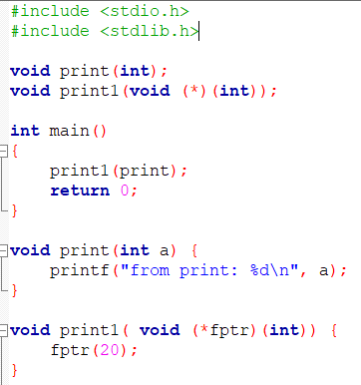
- POINTERS TO FUNCTIONS STORED IN ARRAYS

- 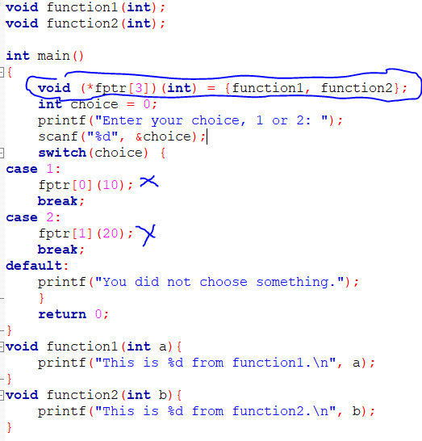

- POINTERS AND MEMORY ALLOCATION
- sum made with pointers
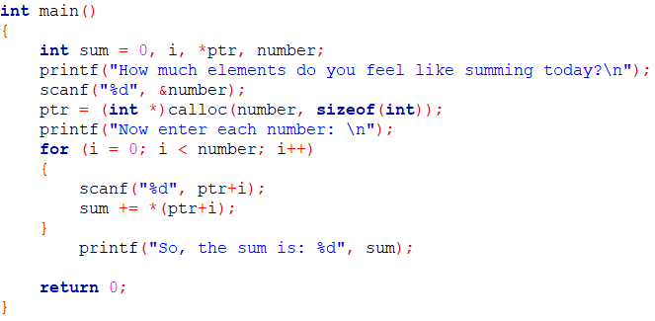

STRING.H !!!!!!!!!!!!!!!!!!!!!!!!!!!!!!!
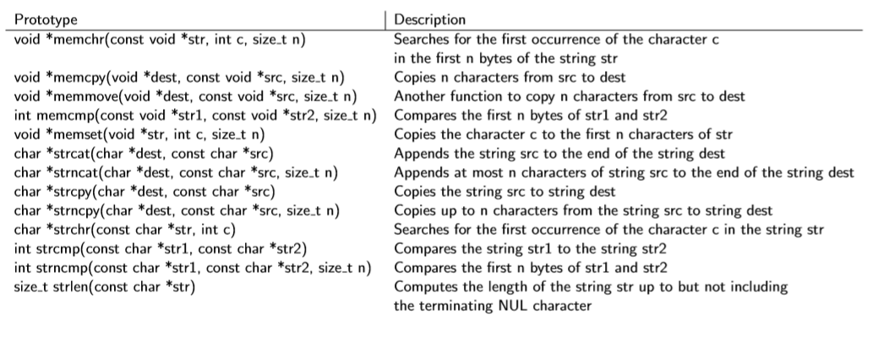

copiaza src peste dest
strcpy(dest, src);
strncpy(dest, src,n);
adauga src la dest
strcat(dest, src);
strncat(dest, src,n);
bonus stricmp(str1, str2); si strnicmp(str1, str2);
compara stringuri fara case sensitivity

compara str1 cu str2
strcmp(str1, str2);
strncmp(str1, str2);
address of the first occurrence, care afisata imi va da restul stringului

cauta c in str1 si ret. address
cauta str2 in str1 si ret. address

strchr(str1, c);
strstr(str1, str2);

COMMAND LINE ARGUMENTS
- argc il gaseste singur,
- trebuie sa introducem cu grija char *argv[]
- orice command line argument care nu este char trebuie cast-uit cu sscanf si transformat in ce vrem noi
sscanf(argv[4], “%d”, &nume_nou);

- 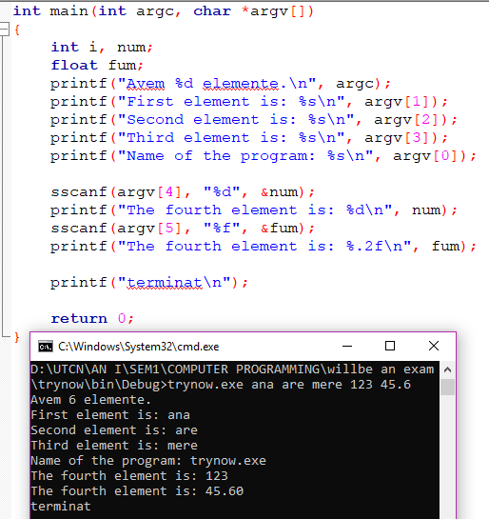

STRUCTURI AND COMPANY
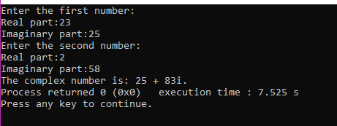

array = vector
string = sir de caractere

